***CODE TO WRITE DATA INTO EXCEL FILE***

**package** apachertr;

**import** java.io.File;

**import** java.io.FileOutputStream;

**import** java.util.Map;

**import** java.util.Set;

**import** java.util.TreeMap;

**import** org.apache.poi.ss.usermodel.Cell;

**import** org.apache.poi.xssf.usermodel.XSSFRow;

**import** org.apache.poi.xssf.usermodel.XSSFSheet;

**import** org.apache.poi.xssf.usermodel.XSSFWorkbook;

**public** **class** writeio

{

**public** **static** **void** main(String[] args) **throws** Exception

{

//Create blank workbook

XSSFWorkbook workbook = **new** XSSFWorkbook();

//Create a blank sheet

XSSFSheet spreadsheet = workbook.createSheet(

" Employee Info ");

//Create row object

XSSFRow row;

//This data needs to be written (Object[])

Map < String, Object[] > empinfo =

**new** TreeMap < String, Object[] >();

empinfo.put( "1", **new** Object[] {

"EMP ID", "EMP NAME", "DESIGNATION" });

empinfo.put( "2", **new** Object[] {

"01", "Adam", "TechnicalManager" });

empinfo.put( "3", **new** Object[] {

"02", "Matt", "Proof Reader" });

empinfo.put( "4", **new** Object[] {

"03", "Smith", "Technical Writer" });

empinfo.put( "5", **new** Object[] {

"04", "Williams", "Technical Writer" });

empinfo.put( "6", **new** Object[] {

"05", "Frank", "Technical Writer" });

//Iterate over data and write to sheet

Set < String > keyid = empinfo.keySet();

**int** rowid = 0;

**for** (String key : keyid)

{

row = spreadsheet.createRow(rowid++);

Object [] objectArr = empinfo.get(key);

**int** cellid = 0;

**for** (Object obj : objectArr)

{

Cell cell = row.createCell(cellid++);

cell.setCellValue((String)obj);

}

}

//Write the workbook in file system

FileOutputStream out = **new** FileOutputStream(

**new** File("Writesheet.xlsx"));

workbook.write(out);

out.close();

System.***out***.println(

"Writesheet.xlsx written successfully" );

}

}

***OUTPUT***

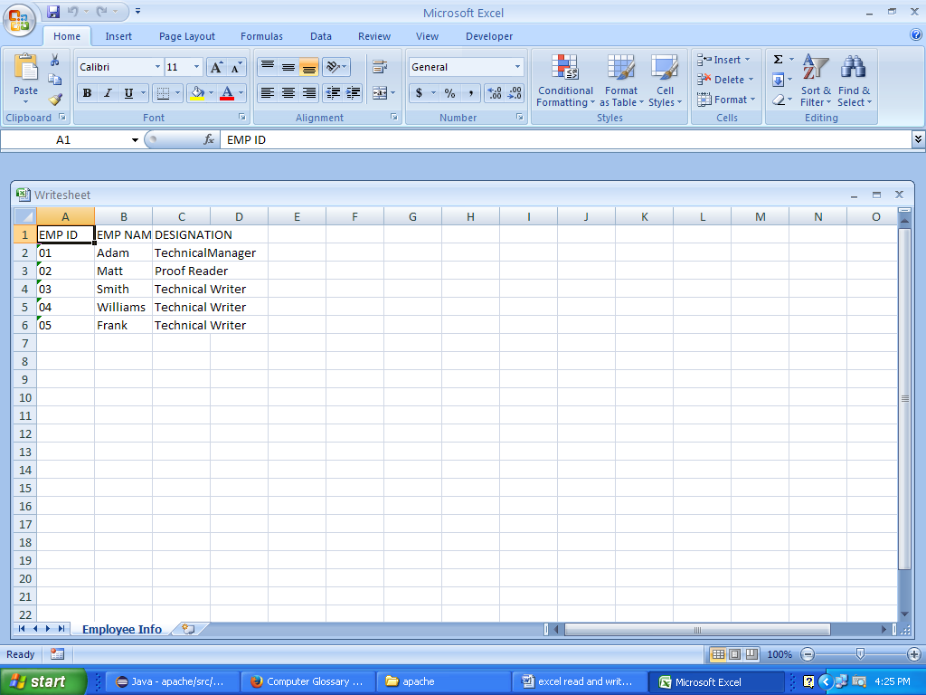

***CODE TO READ DATA FROM EXCEL FILE***

**package** apachertr;

**import** java.io.File;

**import** java.io.FileInputStream;

**import** java.util.Iterator;

**import** org.apache.poi.ss.usermodel.Cell;

**import** org.apache.poi.ss.usermodel.DataFormatter;

**import** org.apache.poi.ss.usermodel.Row;

**import** org.apache.poi.xssf.usermodel.XSSFRow;

**import** org.apache.poi.xssf.usermodel.XSSFSheet;

**import** org.apache.poi.xssf.usermodel.XSSFWorkbook;

**public** **class** newread

{

**static** XSSFRow *row*;

**public** **static** **void** main(String[] args) {

**try** {

FileInputStream file = **new** FileInputStream(**new** File("D:\\Data.xlsx"));

//Create Workbook instance holding reference to .xlsx file

XSSFWorkbook workbook = **new** XSSFWorkbook(file);

//Get first/desired sheet from the workbook

XSSFSheet sheet = workbook.getSheetAt(0);

//Iterate through each rows one by one

Iterator<Row> rowIterator = sheet.iterator();

**while** (rowIterator.hasNext())

{

Row row = rowIterator.next();

//For each row, iterate through all the columns

Iterator<Cell> cellIterator = row.cellIterator();

**while** (cellIterator.hasNext())

{

Cell cell = cellIterator.next();

//Check the cell type and format accordingly

**switch** (cell.~~getCellType~~())

{

**case** Cell.~~CELL_TYPE_NUMERIC~~:

//System.out.print(cell.getNumericCellValue() + "\t");

System.***out***.printf(**new** DataFormatter().formatCellValue(cell) +"\t");

**break**;

**case** Cell.~~CELL_TYPE_STRING~~:

//System.out.print(cell.getStringCellValue() + "\t\t");

System.***out***.print(**new** DataFormatter().formatCellValue(cell) +"\t\t");

**break**;

}

}

System.***out***.println("\t");

}

file.close();

} **catch** (Exception e) {

e.printStackTrace();

}

}}

***OUTPUT***

